**Bail Reckoner**

**Module 1: Analysis using Power BI**

In this module, we focused on understanding and analyzing the dataset before proceeding to model training. This step was crucial in identifying patterns, trends, and anomalies in the data through **Exploratory Data Analysis (EDA)** and visualization. Power BI was used as the primary tool to generate meaningful insights through various charts and graphical representations.

**Dataset Used:**

* **Filename:** a(2).csv
* **Description:** The dataset contains multiple attributes relevant to the analysis, including categorical, numerical, and time-based data.

**Data Visualization in Power BI**

A variety of visualization techniques were implemented in Power BI to explore and interpret the dataset effectively:

**1. Bar Charts & Column Charts**

* Used to analyze the distribution of categorical variables.
* Helps compare different categories based on frequency or numerical values.
* Example: Visualizing the count of different case types or the distribution of bail approvals and rejections.

**2. Line Charts**

* Suitable for tracking trends over time.
* Helps in understanding seasonality, patterns, or any anomalies in time-series data.
* Example: Analyzing trends in legal case filings per month or the fluctuation in bail approvals over time.

**3. Pie Charts & Donut Charts**

* Effective for **percentage-based analysis** where parts of a whole need to be visualized.
* Example: Breakdown of different case outcomes (e.g., bail granted vs. bail denied) or the proportion of different legal charges in the dataset.

**4. Geo Maps**

* Used for location-based insights and geographical analysis.
* Helps in identifying regional patterns or trends related to the dataset.
* Example: Mapping the distribution of legal cases across different states or districts to spot high-risk areas.

**5. Heatmaps & Scatter Plots**

* **Heatmaps:**
  + Used to explore correlations between numerical variables by representing data density with color gradients.
  + Example: Identifying which factors (e.g., case severity, prior offenses) strongly influence bail eligibility.
* **Scatter Plots:**
  + Helps in detecting relationships between two numerical variables.
  + Example: Examining the relationship between case duration and bail approval probability.

Through **Power BI visualizations**, we identified key trends, patterns, and insights within the dataset. This analysis provided a **solid foundation for feature selection** and **data preprocessing**, ensuring that only the most relevant features were used in subsequent **model training and prediction tasks**.

Image :

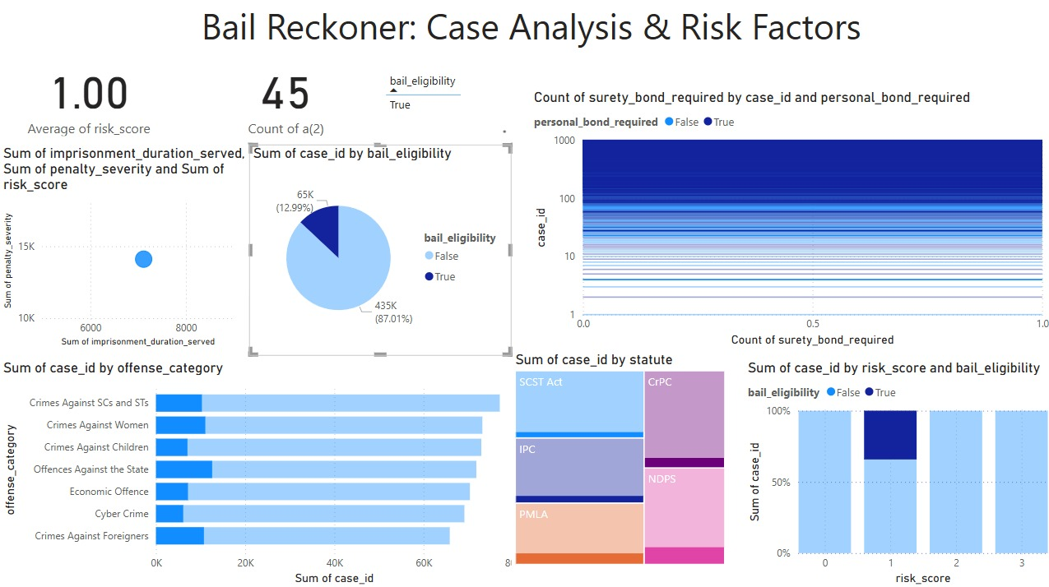

**Fig 1**:This Power BI dashboard titled **"Bail Reckoner: Case Analysis & Risk Factors"** presents insights into bail eligibility, risk scores, and case distributions across different legal factors.

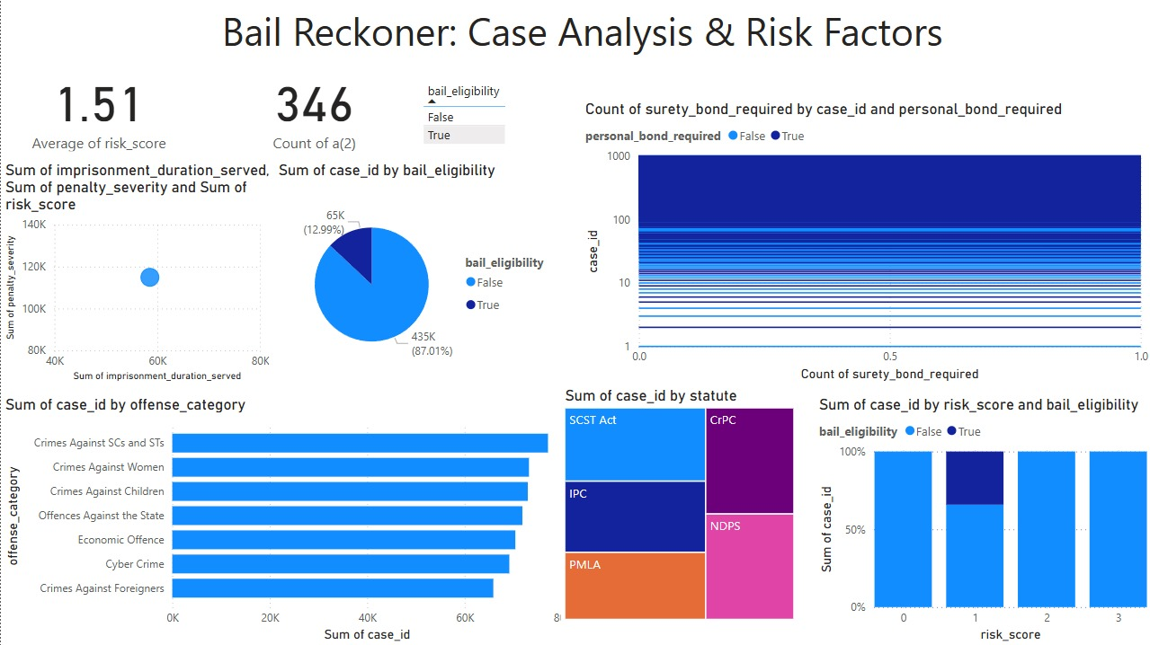

**Fig 2** : This dashboard helps in assessing bail decisions based on **risk, offense type, and legal framework**